Cbeyond

CheckSigning Utility
V2.3-x

June 01, 2006

TABLE OF CONTENTS

1. Change Record 3
2. Installation 4
3. Interface 4
Menus 4
File Exit 4
Window 4
Help About 4
4. Sign Checks Tool 5
Opening the Tool 5
User Interface 5

Change Record
Date | Version | Changes | Made By
03/01/2006 | 1.0 | Initial | Roger Rinesmith
06/01/2006 | 2.0 | Modifications for Cbeyond | Rafael Geraldino

Installation
The program is designed to be deployed via Acorde DSMS. The setup program for the Check Signing Utility installs the necessary files to the IBPM DSMS Masterfile folder. No files are registered. Once the files are installed to the Masterfile folder, the DSMS service will detect their presence within one minute. Once the DSMS service processes the files, they can be installed on a client workstation.
The export utility is automatically installed to a client workstation via DSMS whenever IBPMStatup is run on the client. (This is different from version 1.0.x, which used the command “IBPMStartup /customtool=CheckSigning.exe” at a command prompt on the client workstation. The /customtool command is no longer required.)
Once installation is complete, the utility is executed by running CheckSigning.exe.

The CheckSigning Utility has been developed and tested with IBPM 7.6 SP1. When IBPM is upgraded to a later version, the IBPM files used by the utility will be updated when the IBPM client is updated by DSMS. This could cause the Utility to stop working depending on changes to the supporting files. If this occurs, recompile the Utility with the current version of the IBPM SDK and replace the version in the MasteFiles folder with the newly compiled version. You can then rerun IBPMStartup on the clients to update the installation.

Interface
The window contains a menu bar.

Menus

File Exit
This closes the program. You can also use the keyboard combination of Ctrl+E to do the same thing.

Window
This menu will contain subordinate menus when one of the tools is open. It will list which tool windows are open. This menu can be used to switch between the tool windows if both are open.

Help About
This displays a dialog box that lists the version of the program.

Sign Checks Tool
This tool allows a Controller to quickly and efficiently view the invoices and associated coding for a check run. The idea is that the Controller will use this tool as they are signing the stack of checks.

Opening the Tool
When you open the tool from either the menu or the tool bar, you are immediately prompted to log into IBPM.

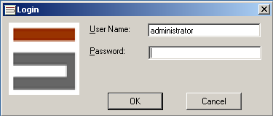

Use the same login as you would to access the full Acorde client. If your login fails, you will receive an error message and can then attempt the login again. If you cancel the login, the tool will still open but you will not be able to view images.

User Interface
Once you login, you will be presented the tool window. The Check Signing Tool window is shown below:
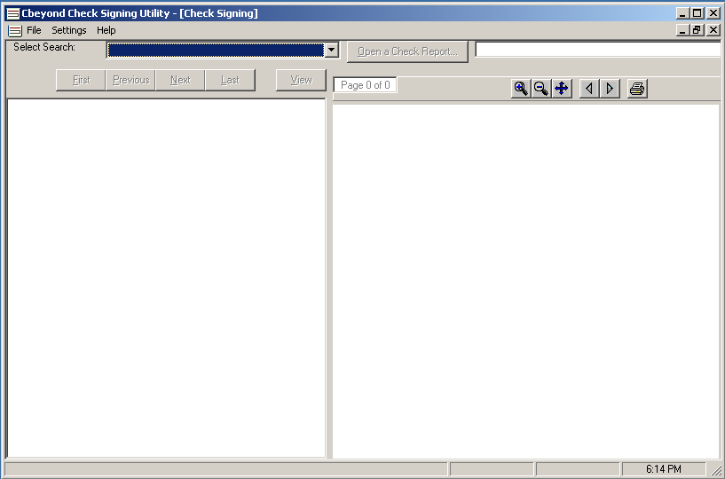

The window contains four primary controls. In the upper left is a drop down box that lists the Saved Searches that the user has rights to access.
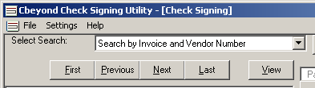

If the user cancelled the login dialog or does not have rights to access any applications, the drop down list will be empty. Use this control first to select your Division’s invoice application.
In the upper right are the controls to select the check report for the check run. The button will not be enabled until you have selected a Saved Search. The user will need to go into their ERP System to generate a check a report and save the output to a file in CSV format.
Then click the Open a Check Report button and use the file dialog to locate and select the report file.
This report file contains information about all of the checks in the check run along with the invoices being paid by the checks and the coding for those invoices.
As soon as you have selected a report file, the tree view control in the lower left portion of the window will display the content of the report file. At the top of the tree is the word Checks which indicates that the next level down contains a listing of all of the checks in numerical order. Each check entry lists the check number, check date, payee, and check amount. When a check node is selected, below it you will see an entry for each invoice being paid by the check. There is an icon by each invoice node of a hand holding up a document representing the invoice. The icon of the selected invoice node is colored light blue and below that node are entries for all the G/L codes and amounts that were used to code the invoice.

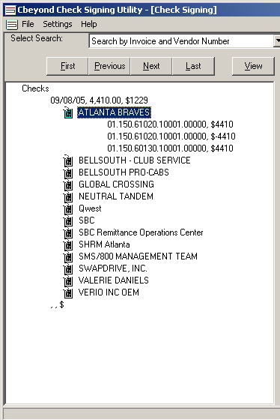

The five buttons above the tree view control are used to navigate the tree. The Next button is automatically selected so that you can simply hit the Enter key on your keyboard to step through every invoice of every check in sequence.
The First button will select the first invoice in the tree. The Last button selects the last. The Previous button will select the previous invoice in the tree. The View button will display the selected invoice. You can invoke any of the buttons by clicking on them or using the Alt key in combination with the underlined letter in the key’s caption. For example, Alt+L does the same thing as clicking the Last button.
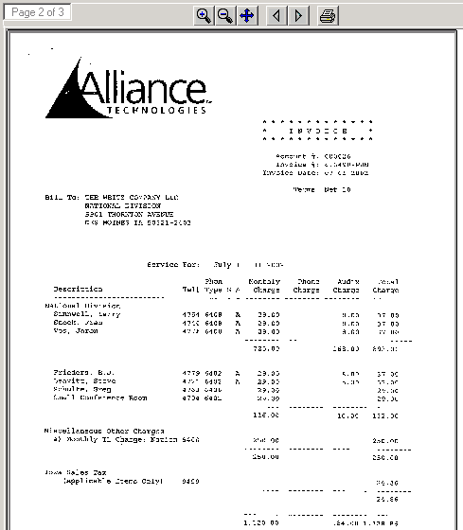When the check report is selected and loaded into the tree view, the first invoice is automatically selected and loaded into the viewer control. The viewer control displays the invoice image and has a tool bar with tool buttons for manipulating the image. On the left of the toolbar is box that lists the page number and the page count for the document. The magnifying glass with the plus sign is used to zoom in and the magnifying glass with the minus sign is used to zoom out. The four way arrow zooms the image to fit the window. The left arrow head moves to the previous page of the document and the right arrow head moves to the next page of the document. The Previous and Next tool buttons will be grayed out when there is no previous or next page, respectively. The Print button is used to print the image.

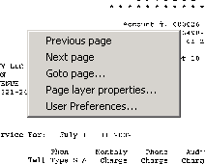You can also right-click on the image and obtain a pop-up menu. This is the same pop-up menu as the IBPM client viewer.

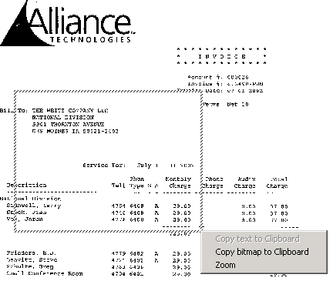You can also left click and drag a box over the image. When you release the left mouse button, a pop-up menu will appear that allows you to Zoom or copy that portion of the image to the clipboard so it can be pasted into another program.
There are no annotation features in the viewer. You can view annotations in accordance with your annotation security level, but you cannot edit or add annotation with this tool.

When you use the First, Last, Next, or Previous buttons, the invoice image will automatically be loaded into the Viewer. You can also use the mouse to click on a node in the tree view to select and expand it. When you do this however, the associated invoice image is not automatically loaded. To load the image in this case, use the View button. This is so that you can use the mouse to quickly navigate in the tree view without having to wait for the image to load at each node.
If the tree view is the active control (which happens when you click on it), you can also use the keyboard arrow keys to navigate up and down the tree and expand and contract the nodes.
The program allows you to open another instance of the tool even though there is one already open. This is one of the side effects of a multi-tool program. Even though you can do this, there is no benefit to doing so and it actually degrades the performance by using up more memory. If you open up more than one copy of the tool, just close the extra copies.
When you are done with one report, you can open another or close the program. The user must decide whether to delete or save the check report file when they are done with it. The Check Signing tool will not delete the report file.

